Проблемы вымирающих языков и интеграции этнических меньшинств в англоязычное пространство современного мира.
Тип урока: урок-дискуссия
Ролевая игра «Совет старейшин».
Цель: Использование изучаемого языка на этапе творческого его применения в качестве средства общения, формирование подлинной потребности в использовании изученного материала для естественного общения с носителями языка. Развитие коммуникативной компетенции учащихся, умения осознанно выбирать средства для выражения мыслей, формирование чувства языка, памяти, логики (анализа, синтеза, умозаключения).
Задачи:
Познавательный аспект: знакомство с языковыми и социальными, культурными проблемами мира этнических меньшинств.
Воспитательный аспект: создание ситуаций успеха и самореализации личности в различных видах речевой деятельности, тренировка умения принимать ответственные решения, касающиеся социальной сферы. Воспитание толерантности. Привитие навыка оценивать себя критично .
Учебный аспект: тренировка навыка протяженного аргументированного высказывания, обмена мнениями, выдвижение аргументов «за» и «против», умение отстаивать свою точку зрения. Развитие навыков ведения беседы в рамках конструктивного диалога.
Развивающий аспект: развитие способности учащихся принимать участие в дискуссиях «круглого стола», обсуждение проблемы вымирающих языков. Формирование и развитие учебно-организационных умений в самостоятельной и групповой работе. Умение активировать свой словарный запас в ситуации общения.
Оборудование урока: мультимедийный проектор, экран. Презентация power point, карточки с опорными характеристиками для ролевой игры, презентации учащихся « АЯ в глобализованном пространстве современного мира».

Ход урока:
Организационный момент и приветствие... Good morning pupils! I’m glad to see you… How are you?........ Wonderful! Today’s lesson is going be very interesting!
Объявление целей и задач урока. Look at the screen, please! I would like to suggest you the idea of performing the role play… Should English be the first language for the Bongou people?..

Слайд 1
Role Play
Should English be the first language for the Bongou people?
- You will participate in a discussion among the Bongou people.
- The aim is to decide which should be the first language for the people: Bongou or English.

Objectives
We will
  - think critically about the problem of dying languages
  - take part in a discussion
practise making a responsible decision on social problems

Вступление.
Немного истории. Причины и пути становления АЯ, как международного. Необходимость изучения и использования АЯ, как инструмента общения в диалоге культур.
Т. Today when English is one of the major languages in the world, it requires an effort of the imagination to realize that this is a relatively recent thing – that in Shakespeare’s time, for example, only a few million people spoke English, and the language was not thought to be very important by the other nations of Europe, and was unknown to the rest of the world…

выступления учащихся с презентациями
S1 слайды

S2 слайды (Приложение 2)

S3 слайды

Role-play.
T. Now, my dear friends, pretend that you are not in Russia, but in a far-away country among Bongou people. You will participate in a discussion about future of their society. The aim is to decide which should the first language for people: Bongou (native) or English.
Round-table talk.
To participate in the round-table play you are to accept the role that may seem quite unusual, you are to take a role in order to understand other points of view better. Now we are going to split into groups of seven and work as two teams. And I ask you to choose a role from the list.
Слайд 2
Characters to act:

- Chief of the Bongou
- A Hotel owner
- Bongou Poet
- A Bongou Cape Town University graduate
- A Bongou mother
- A western linguist
- A fifteen-year old Bongou

You are getting your own cards and I ask you to study them please. (Приложение 1)
Cards
- Chief of the Bongou
You are the chief of the Bongou. Your forefathers wanted you to preserve the Bongou people and their culture. You feel that the assimilation process is strengthening and you are afraid that losing their language will make the Bongou lose their identity.
NB It Is your responsibility to chair the discussion, to give the floor to the participants, to organize a vote and to round up the discussion. You need to know the position of every participant as it will be your responsibility to announce the speakers. Results of the vote will be announced by the poet (card #3).

- A Hotel owner
You own the biggest hotel in the country and you know quite well that English is a way to another world, a chance to get a job with foreigners. At the same time you understand that if the Bongou lose their culture, the tourists won’t travel to your country as they are very interested in the Bongou culture. Present arguments for and against, and during the discussion come to a decision.

- Bongou Poet

You are a poet and your poems are appreciated by the Bongou Council. You are worried by the fact that the younger generation doesn’t care much for literature in Bongou. You are afraid that your language may become extinct.
NB it is your responsibility to take notes during the vote and to report the results.

- A Bongou Cape Town University graduate
You are a native speaker of Bongou and a Cape Town University graduate. You know having a global language is more convenient as it makes communication easier. But the Bongou culture is unique and it needs protection. You cannot take definite position. Try to do it later during the discussion.

- A Bongou mother
You are a mother of three schoolchildren at English-speaking boarding school. They don’t speak Bongou much at school but English has helped them learn to use computers and you think they will have a good future. On the other hand, you are concerned that in future your children and grandchildren won’t speak their native language.
You cannot take a definite position. Try to decide on during the discussion.

- A western linguist

You are a linguist. You understand that Bongou is an endangered language. It lacks a proper written form and is suffering from cultural assimilation.
You are convinced that diversity is the key to the survival of Bongou and you are planning to petition the UN with a request to save Bongou.

- A fifteen-year old Bongou
You are fifteen. Next year you are going to an English-speaking high school. You have read that English is dominant and is becoming a global language, and you can’t understand your parents and grandparents, who try to make you speak Bongou.

T. I want to tell you that roles 1 and 3 demand additional work and attention! They are going to be responsible for the procedure for taking a vote!

(in case the class cannot be divided into groups of seven it’s possible to make group smaller, leaving cards 2,4,5 only as it is necessary to have an equal number roles, defending opposite opinions).

T. Is everything clear for you?....................................
The play is going to be very interesting . We participate in a round-table discussion! As you practice giving a longer talk presenting arguments and making decision I ask you to prepare plan of short presentation of your ideas according to your role cards. Structure your talk in the following way…

Talk Structure
слайд 3
Please look it through…

Preparation
T. And you have 5-7 minutes to prepare for the activity don’t forget, please that you should take notes of the questions during the presentation of all participants in the discussion.
………………………………………………………………………………………

T. Now I see that you are ready to start… but first of all I want to introduce the chief as a chair person of group A and group B as well, and remind you that chief of the Bongou people is respectable and he (she) is a senior chief of African Ethnic Minorities!
So treat him in a proper way!
Groups have their discussions at the same time. I remind you that we are in Africa (as we are role-playing) so it is necessary to play your roles up to the end. And you will not be able to get any help from me after the activity begins. Also you should not call anybody by usual name.
Activity
Now we start and I ask you to go through these stages: Give presentations of your ideas, listen to the others, ask the questions of the other participants and answer them….
Работа в группах. Выступления «персонажей». Дискуссия.
………………………………………………………………………………………………….
T. Now it’s time to make your choice between Bongou and English! Vote for a decision!
………………………………………………………………………………………

Завершение дискуссии. Итоги голосования.
Follow up
T. Well done! I ask you to report the results of your group discussion to the class! Dear Chiefs, the floor is yours! ……………………………………………………………..
Объявление итогов голосования и вердикта.
T. Now the question is: has your personal attitude to the problem changed? Why? How?
P.…………………………………………………………………………….

Debriefing at the end of the activity.
T. So, my dear friends, let’s return to Russia, to our classroom, remembering our real names. My question is: how you felt during the role-play?
P………………………………………………….
T. Was it easy or difficult to express the opinion that you didn’t share?
P………………………………………..
T. What have you learned and whether you see any relevance to the situation in Russia?
P…………………………………..
T. Great! Your point of view is clear for me! I can’t but agree with you. I want you to relax looking at the screen!

слайд 4
Net Slang
T. Do you use any abbreviations from the list? Do you know quite right their meaning? As for me I have never heard about some of them. Is it natural for teenagers? …………Good! I’ll do my best to remember some of Net Slangs!
P……………..
Pretend that you are chatting on the computer using the Chat language and exchange written messages. Use of as many expressions as possible! It’s your hometask!
Now I have got some evaluation cards of our lesson for me and for you.

cлайд 5
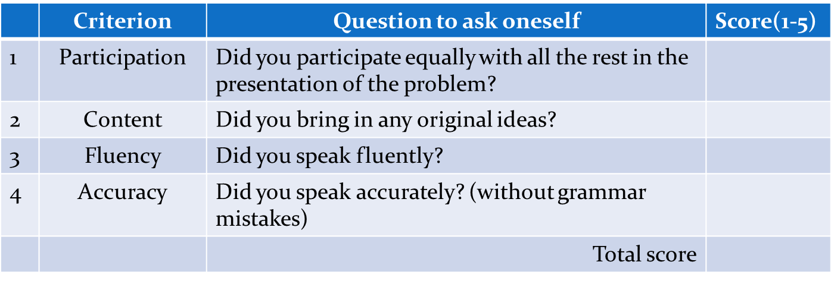

T. Let’s have a look at them! Try to fill in……………………………………………………………………. You can use the idea of quality of your work, chatting with friends in the net and writing messages. It’s you hometask, remember?......................
As for me I am very pleased with your participation in group work, you performed your characters artistically, I enjoyed watching the «real people of Bongou»!
Evaluation card for the teacher (Приложение 3)
But talking about your individual work, I’d say it could be better in grammar. You talk emotionally and (it often happens) miss simple things- mixing pronouns, plural and singular and so on. It’s typical for emotionally coloured speech. But you are just pupils! To err is human!” Err are humanum est.”(latin) Человеку свойственно ошибаться!

Thank you for your work and have a nice day! See you!

Физкультминутка может быть дана после голосования, я предлагаю упражнение на релаксацию: дыхательная гимнастика, упражнения для глаз, расслабление мышц лица, снятие напряжения позвоночного столба. Музыкальное сопровождение (Чайковский П.И. 2 часть фортепьянного концерта/Рахманинов сюита 2 часть/The Beatles).

Справочная информация.

Бонго – многозначный термин.
- народ
- животное, вида антилопы
- латиноамериканский барабан
- Регион – Африка, страна проживания – Судан. Судан – полиэтническая страна, насчитывающая более пятисот этнических групп. Бонго – народ, проживающий на территории Судана в южной части региона Бахар-Эль-Газель. Отдельные группы проживают в Экваториальном Регионе.
Род занятий – ручное земледелие, рыболовство, скотоводство.
Pемесла: кузнечное (лучшее в регионе), резьба, гончарное дело. Изготавливают ложки, украшения из рогов животных с гравировкой, а так же табуреты, вырезанные из целого куска дерева.
Жилище – круглые хижины с глинобитными полами и травяной крышей (бамбук или кора). Мужская одежда – набедренник из шкур, женская – пучок травы на шнурке вокруг бедер.
Татуировка у замужних женщин – в нижней губе лабретка.
Пища – растительная.
Вождь – традиционная функция – вызывание дождя.
Поклонение духам природы. Развиты песенные жанры.

Приложение 1
1. Chief of the Bongou
You are the chief of the Bongou. Your forefathers wanted you to preserve the Bongou people and their culture. You feel that the assimilation process is strengthening and you are afraid that losing their language will make the Bongou lose their identity.
NB It Is your responsibility to chair the discussion, to give the floor to the participants, to organize a vote and to round up the discussion. You need to know the position of every participant as it will be your responsibility to announce the speakers. Results of the vote will be announced by the poet (card #3).

2. A Hotel owner
You own the biggest hotel in the country and you know quite well that English is a way to another world, a chance to get a job with foreigners. At the same time you understand that if the Bongou lose their culture, the tourists won’t travel to your country as they are very interested in the Bongou culture. Present arguments for and against, and during the discussion come to a decision.

3. Bongou Poet

You are a poet and your poems are appreciated by the Bongou Council. You are worried by the fact that the younger generation doesn’t care much for literature in Bongou. You are afraid that your language may become extinct.
NB it is your responsibility to take notes during the vote and to report the results.

4. A Bongou Cape Town University graduate
You are a native speaker of Bongou and a Cape Town University graduate. You know having a global language is more convenient as it makes communication easier. But the Bongou culture is unique and it needs protection. You cannot take definite position. Try to do it later during the discussion.

5. A Bongou mother
You are a mother of three schoolchildren at English-speaking boarding school. They don’t speak Bongou much at school but English has helped them learn to use computers and you think they will have a good future. On the other hand, you are concerned that in future your children and grandchildren won’t speak their native language.
You cannot take a definite position. Try to decide on during the discussion.

6. A western linguist

You are a linguist. You understand that Bongou is an endangered language. It lacks a proper written form and is suffering from cultural assimilation.
You are convinced that diversity is the key to the survival of Bongou and you are planning to petition the UN with a request to save Bongou.

7. A fifteen-year old Bongou
You are fifteen. Next year you are going to an English-speaking high school. You have read that English is dominant and is becoming a global language, and you can’t understand your parents and grandparents, who try to make you speak Bongou.

Приложение 2
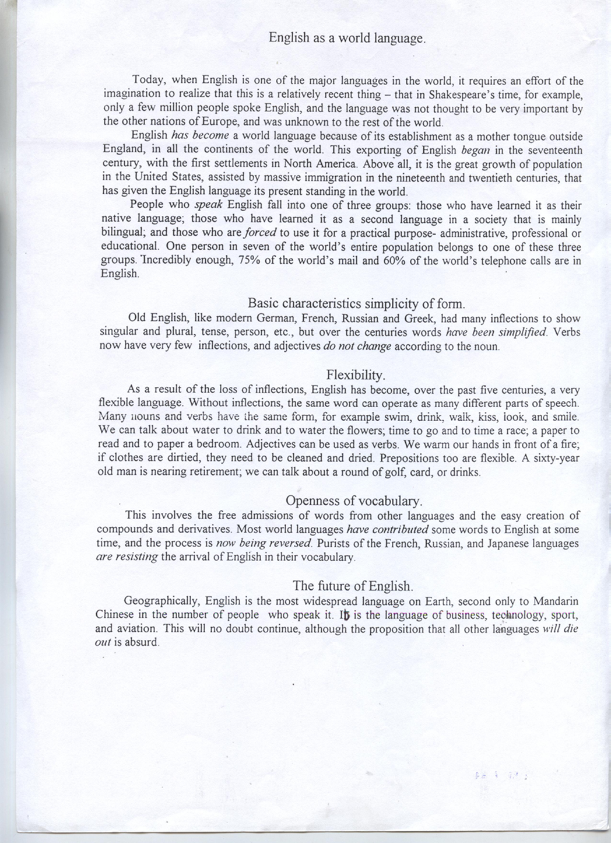
Приложение 3
Evaluation card for the teacher

Group work:
Participation in group work
Individual work:
Arguments
Task achievement
Appropriateness of language
Fluency
Accuracy and structure

